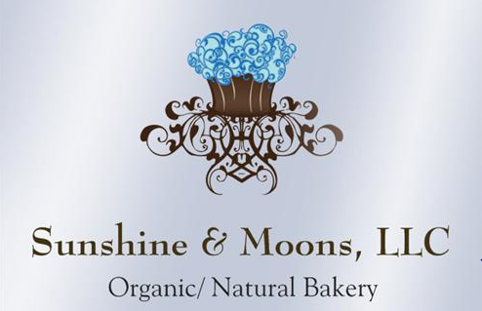

Breakfast/Brunch Menu

Muffins
Standard Size ($3.50/each) /GF $3.75
Jumbo Size ($5.75/each)/ GF $6.00
Blueberry Streusel Muffins
(GF/ Dairy Free available)
Morning Glory Muffin
(Carrot, Cranberry, Flax, Pumpkin Seed Muffins - GF/ Dairy Free available)
Vegan Raspberry Pecan Muffins
Banana Chocolate Chip Muffins
Scones ($3.50/each)
Cranberry Orange
Blueberry
Lemon Herb
Breakfast Bar Options
Raspberry Oat Bars $5.50
GF/ V Mixed Berry Crumble Bars $6
GF/ V Apple Crumble Bars $6

Sweet Breads
Regular Breads ($15.50 – $16.50/each)
**GF/ DF Breads available ($16.50/each)
Zucchini** Banana**
Pumpkin** Chocolate Zucchini**
Lemon Poppy** Blueberry Streusel
Cream Cheese Pound Cake
Brioche Loaves
(Great for French Toast)

French Style Quiche
Spinach Mushroom Quiche $30
(GF available $32)
Spinach Bacon Quiche $30
Quiche Lorraine (Bacon/Onion) $30
(GF available $32)
Advance 4 day Notice Items
Cranberry Toffee Pecan Rolls $5.50
Cinnamon Rolls $5 /GF $5.50
Buttermilk Biscuits 6 pk $12
(GF 6 pk available $14)

***Gift Baskets Available ***Gift Certificates Available***
***Ask about Gluten Free & Vegan Options***
Place your Special Order Today!
Place your order the day before for the next day pick up on most items!!

