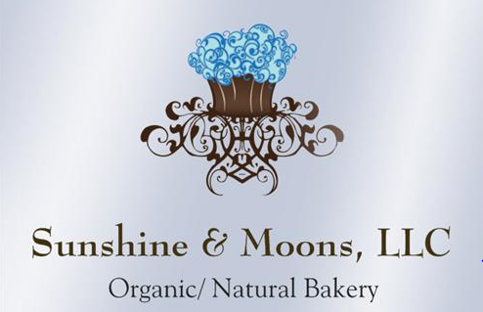
Holiday Menu

Near Death Chocolate Cake (GF)
Stout Gingerbread Bundt Cake
Sticky Toffee Pudding w/ Toffee Sauce
Triple Chocolate Mousse Cake (GF)
Yule Logs (GF, V & R)
Eggnog Cheesecake (GF)
Decadent Mint Brownies (GF/ V & R)
Gift Baskets & Gift Certificates Available
Pies (GF, V, R)
Apple, Cherry, Mixed Berry Crumble, Pumpkin Pie, Pecan, Lemon Bluberry
Key lime Pie (GF & R)
Chocolate Silk Pie (GF & R)
Assorted Cookie & Candy Boxes
Decorated Sugar Cookies (GF & R)
Candy, Truffles & Confections (GF, V & R)

Savory Organic Pie Options (Take n Bake)
Savory Rosemary Chicken Pies w/ Herb Double Crust $34/Each
GF Savory Rosemary Chicken Pies w/ Herb Double Crust $37/ Each

Organic Quiche

Quiches $30.00/Each GF Quiches $32/Each
Spinach Mushroom Quiche (GF & R), Spinach Bacon Quiche (R), Quiche Lorraine (R & GF) (Bacon/Onion)

Organic Bread/ Breakfast Options
Brioche Slider Buns (12pk) $8/ea GF Brioche Buns $1.50/ each
Brioche Loaves $10/ea Sourdough Bread $7.50/ea
Garlic Rosemary Sourdough $8/ea Olive Feta Sourdough $9/ea
Scones $3.50/each (Cranberry Orange, Blueberry, Lemon Herb)
5 day pre-order notice: Cinnamon Rolls & Cranberry Toffee Pecan Rolls $5
Sweet Breads $16 -17/Each **GF Sweet Breads $17 – 17.50/each
(**Zucchini, **Pumpkin, Blueberry Struessel, **Banana, **Lemon Poppy, Cream Cheese Pound Cake, **CC Zucchini, Cranberry Orange Struessel (seasonal)
Mini Loaves (Only R. Lemon Poppy & Pumpkin) $7

